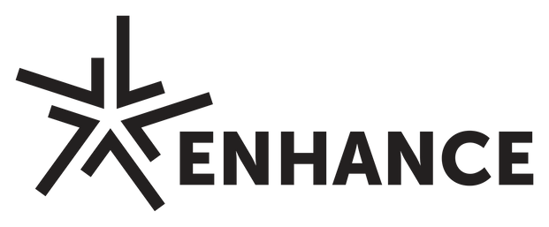
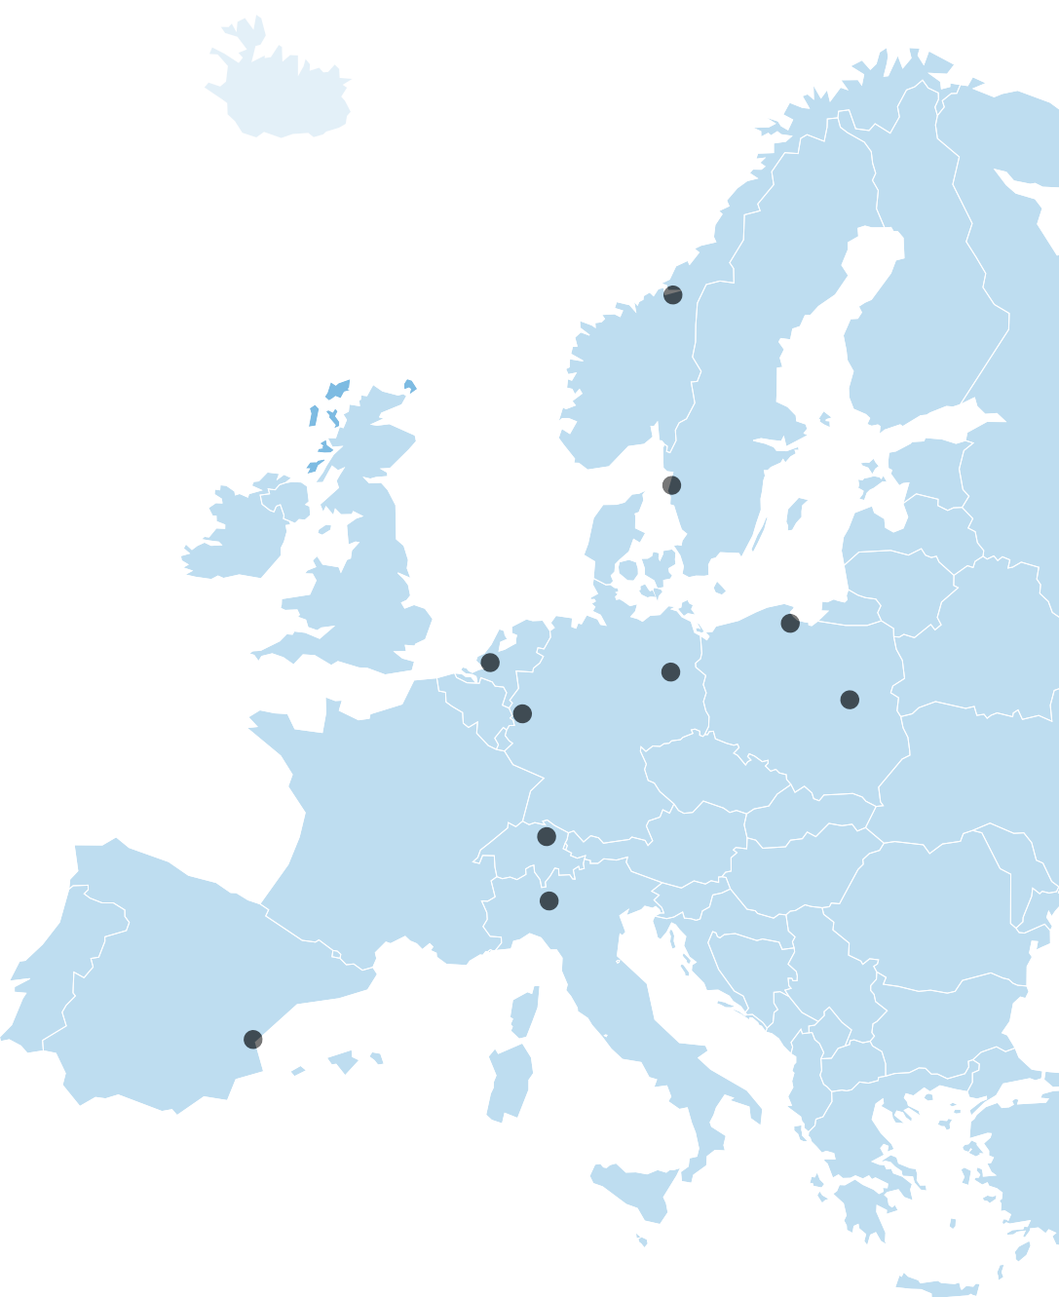


Call for

Blended Intensive Programmes*

Academic year 2026/27
*supported by Erasmus+ and Movetia funding



ABOUT ENHANCE

The ENHANCE Alliance
The ENHANCE Alliance is a network of ten leading European Universities of Science and Technology, supported by the European Universities Initiative and national funding agencies. Its mission is to create a shared European academic space that connects technological innovation with societal and environmental challenges.
ENHANCE promotes interdisciplinary and transdisciplinary education, inclusive learning environments, and innovative approaches to teaching and learning. Through closer alignment of educational offerings and administrative processes, the Alliance is working towards a European Education Without Barriers and a shared One Campus vision.

Our ENHANCE members
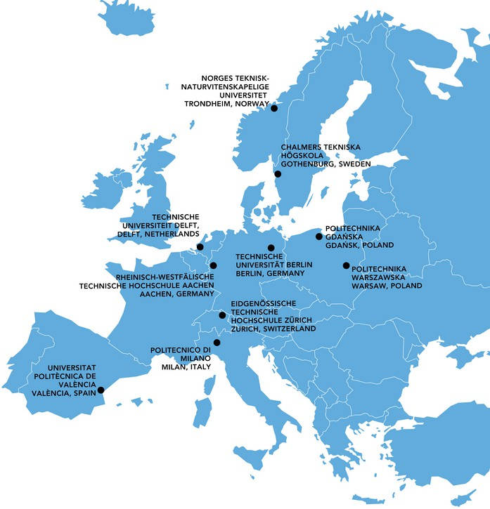
Chalmers University of Technology (Sweden)
Delft University of Technology (Netherlands)
Eidgenössische Technische Hochschule Zürich
(Switzerland)
Gdańsk University of Technology (Poland)
Norwegian University of Science and Technology
(Norway)
Politecnico di Milano (Italy)
Rheinisch-Westfälische Technische Hochschule Aachen (Germany)
Technische Universität Berlin (Germany)
Universitat Politècnica de València (Spain)
Warsaw University of Technology (Poland)

ABOUT THIS CALL

What are ENHANCE Blended Intensive Programmes?
ENHANCE Blended Intensive Programmes (BIPs) are short-term, intensive learning opportunities that are designed and implemented in a blended format, i.e., with a virtual and a physical component embedded in the programme design. They aim to foster international cooperation in teaching and learning among the members of the ENHANCE Alliance.
The physical component consists of a 5-10 days in-presence phase for which participating learners and teachers are eligible to apply for a mobility scholarship. The virtual component may involve any amount of online learning and can take place either before and/or after the physical component.
BIPs are designed and implemented by a consortium of at least 3 member universities of the ENHANCE Alliance (or 2 if coordinated by ETH). This BIP consortium is always composed of a coordinator, also serving as the host institution for the in-presence phase, and several partners that contribute to the design and implementation and/or send their students or staff members.

Requirements
- The BIP consortium must include at least 3 ENHANCE universities in 3 different countries (if coordinated by ETH, 2 ENHANCE universities (ETH + 1 partner) in 2 different countries is sufficient).
- Proposals must follow the programme structure: virtual component + 5-10 days physical component (5 days being the recommended length).
- Participating students must be awarded with at least 3 ECTS.
- A minimum number of 10 learners receiving an Erasmus+ scholarship (“Erasmus+ mobile learners”) need to participate in the programme (we recommended to plan with at least 25-30 learners).

Funding
ENHANCE BIPs are funded by Erasmus+ (or, if coordinated by ETH, Movetia Switzerland). Funding is composed of organisational support funds plus mobility scholarships for teachers and learners participating in the physical component/in-presence phase. The total amount of funding depends on the number of teachers and learners participating in the BIP and the institution-specific regulations of the involved partners.

Support
For any question, please contact your local ENHANCE contact person:
Chalmers: Andreas Eriksson (eandr@chalmers.se)
ETH Zurich: Julia Wussler (julia.wussler@akd.ethz.ch)
Gdańsk Tech: Maria Doerffer (maria.doerffer@pg.edu.pl)
NTNU: Wolfgang Laschet (wolfgang.laschet@ntnu.no)
POLIMI: Rosella Magni (rossella.magni@polimi.it)
RWTH: Sabine Derichs (sabine.derichs@zhv.rwth-aachen.de)
TU Berlin: Julian Irlenkäuser (j.irlenkaeuser@tu-berlin.de)
TU Delft: Pelle Alons (p.alons@tudelft.nl)
UPV: Javier Calvo Diaz (jacaldi@upv.es)

WUT: Anna Smulska (anna.smulska@pw.edu.pl)

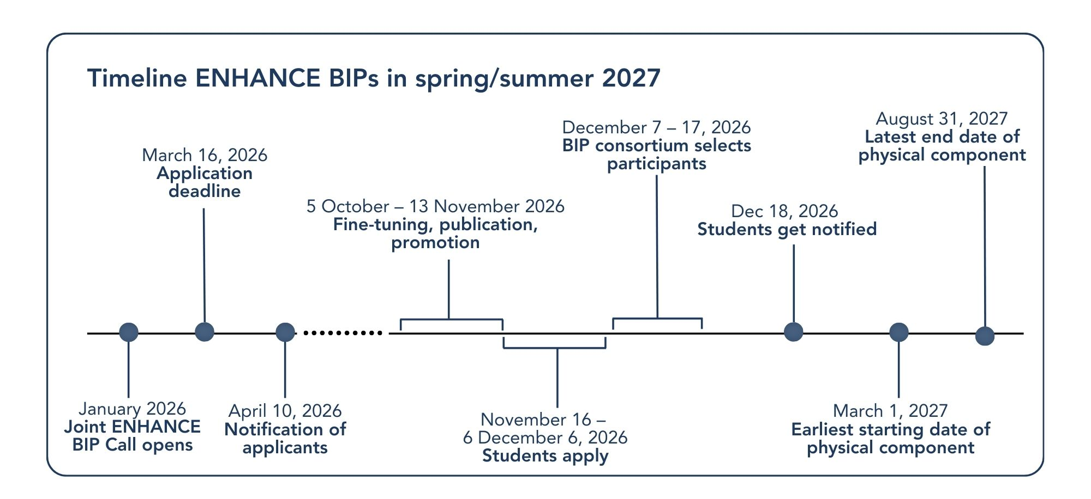
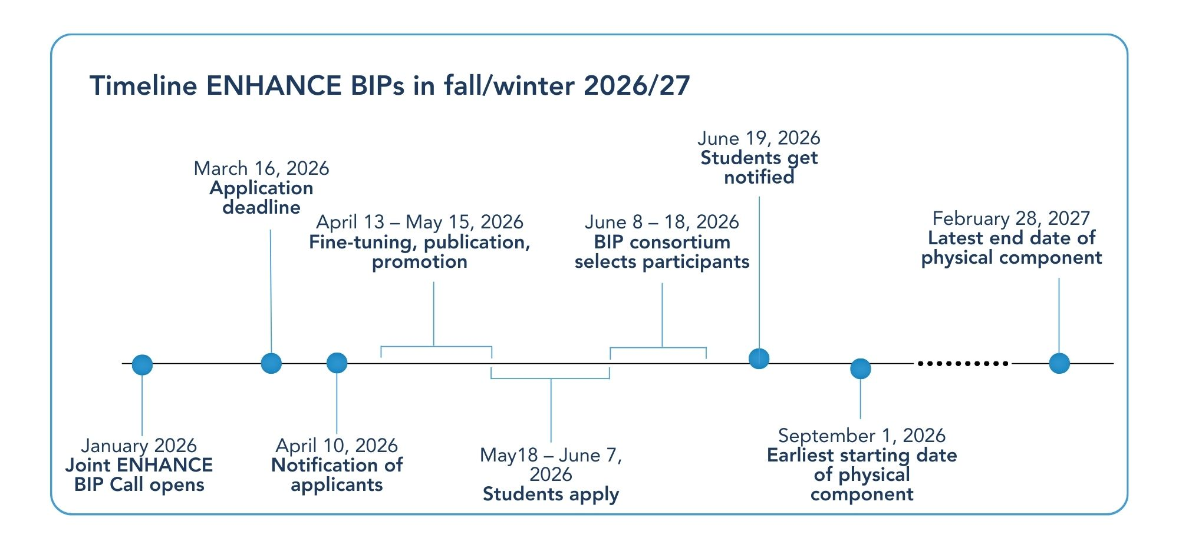
PROJECT TIMELINE

APPLICATION FORM

BIP Consortium

Coordinating university*
The consortium must include at least 3 ENHANCE universities (the coordinator + 2 partners) in 3 different countries. If ETH is the coordinator, 2 ENHANCE universities (ETH + 1 partner) in 2 different countries is sufficient.

- Chalmers Tekniska Högskola AB (Sweden)
- Eidgenössische Technische Hochschule Zürich (Switzerland)
- Norges Teknisk-Naturvitenskapelige Universitet (Norway)
- Politechnika Gdańska (Poland)
- Politechnika Warszawska (Poland)
- Politecnico di Milano (Italy)
- Rheinisch-Westfälische Technische Hochschule Aachen (Germany)
- Technische Universität Berlin (Germany)
- Universitat Politècnica de València (Spain)

Consortium partners*
The consortium must include at least 3 ENHANCE universities (the coordinator + 2 partners) in 3 different countries. However, if ETH or TU Delft join as partners, at least 2 other partner institutions must be involved.
- Chalmers Tekniska Högskola AB (Sweden)
- Eidgenössische Technische Hochschule Zürich (Switzerland)
- Norges Teknisk-Naturvitenskapelige Universitet (Norway)
- Politechnika Gdańska (Poland)
- Politechnika Warszawska (Poland)
- Politecnico di Milano (Italy)
- Rheinisch-Westfälische Technische Hochschule Aachen (Germany)
- Technische Universität Berlin (Germany)
- Technische Universiteit Delft (Netherlands)
- Universitat Politècnica de València (Spain)

Academic coordinator(s) of the programme*
Please list the following information for all academic coordinators: name and surname, position, email, faculty or department and university.
Insert text here…

Other partners (if applicable)
Non-ENHANCE higher education institutions, or external organisations such as NGOs, companies, public institutions, or other relevant stakeholders.
Insert text here…

BIP Description

BIP title*
Insert text here…

Short title/acronym (if applicable)
Insert text here…

Edition*
- First edition (new BIP)
- New edition (remake of a BIP)

Main educational areas*
Insert text here…

Description of the BIP*
Insert text here…
Language(s) of instruction (only if other than English)
Please select the main language(s) for the BIP:
- Dutch ☐ German ☐ Italian ☐ Norwegian ☐ Polish ☐ Spanish ☐ Swedish ☐ Ukrainian
☐ Other: ____________________________________

Objectives and learning outcomes*
  - State the main objectives of the BIP.
  - Define the specific learning outcomes (knowledge, skills, competences) to be achieved.

Pedagogical approach*
Insert text here…
  - Describe the teaching and learning methods to be used (e.g. student-centred, active, blended, challenge-based, research-based).
Insert text here…
Assessment method*
  - Describe the planned assessment methods (presentations, exams, portfolios, group work, etc.).
Insert text here…

Partner roles and contributions*
  - Describe how the BIP is co-designed and co-delivered by the partner universities.
  - Explain the specific roles and responsibilities of each partner.
Insert text here…

Workload and ECTS Awarded

Contact hours (guided learning)*
Enter the estimated number of hours for guided learning activities (e.g., lectures, workshops, interactive sessions) in both the physical and virtual components.
Virtual contact hours:
Physical contact hours:

Self-study and asynchronous teaching hours (independent learning)*
Enter the estimated hours for independent learning, assignments, asynchronous teaching and other self-directed study activities.
Insert text here…

Total workload
= SUMMARY from guided learning + independent learning hours

ECTS awarded*
Based on the total student workload, calculate the equivalent ECTS credits for the BIP. Note that 1 ECTS credit corresponds to approximately 25-30 hours of total student effort.
Insert number of ECTS here…

Mobility Design

Physical component
Hosting university and location*
Insert text here…
Planned dates*
Must be min. 5 consecutive days during the 2026/27 ENHANCE academic year (01.09.26 – 31.08.27). Longer durations than 5 days are possible but not recommended.
Insert dates here…

Description of planned activities for physical component*
Briefly describe the activities for the physical component.
Insert text here…

Virtual component
Planned dates*
Must be during the 2026/27 ENHANCE academic year (01.09.26 – 31.08.27).
Insert dates here…

Description of planned activities for virtual component*
Briefly describe the activities for the virtual component.
Insert text here…

Student participation details
Profile of participants*
- Indicate the fields of study, disciplines, or backgrounds that the BIP is primarily addressed to.
    - Mention whether the BIP is open to students from all fields or targeted to specific profiles.
Insert text here…
Prerequisites (if applicable)
Indicate any entry requirements for students (e.g., prior coursework, language proficiency, specific skills) and, if applicable, specific technical equipment needed for participation.
Insert text here…

Target group(s)*
- Bachelor students
- Master students
- Doctoral candidates
- Administrative staff
- Teaching staff
- Other (please specify):

Participation of diverse learner groups and accessibility*
    - Describe possible measures to encourage the participation of learners with fewer opportunities
(economic, social, cultural, geographical, or disability-related).
    - Describe steps taken to ensure that both the physical and the virtual mobility are accessible (venues, facilities, platforms etc.).
Insert text here…
Total number of places available*
Insert number here…

Planned visiting teaching staff from ENHANCE universities (other than the host university)*
Insert number here…

CONFIRMATION AND SUBMISSION

Before submission, please confirm the following:

Applicant declaration*

- I confirm that I have informed my university’s Erasmus+/International Office and – if required - my faculty leadership about this proposal.
- I confirm that this application is complete, accurate, and meets the eligibility requirements of the call.
- I confirm that the proposal involves at least 3 ENHANCE universities (in case of Switzerland 2).
- I confirm that the BIP awards at least 3 ECTS, corresponding to 75-90 hours of student workload.
- I confirm that the BIP includes a 5-day physical component and a virtual component, integrated into one programme.
Signature by the academic coordinator of the coordinating university*

Name, date

Submission
Please submit your proposal as a PDF file via email to your local contact point:
Chalmers: Andreas Eriksson (eandr@chalmers.se)
ETH Zurich: Julia Wussler (julia.wussler@akd.ethz.ch)
Gdańsk Tech: Maria Doerffer (maria.doerffer@pg.edu.pl)
NTNU: Wolfgang Laschet (wolfgang.laschet@ntnu.no)
POLIMI: Rosella Magni (rossella.magni@polimi.it)
RWTH: Sabine Derichs (sabine.derichs@zhv.rwth-aachen.de)
TU Berlin: Julian Irlenkäuser (j.irlenkaeuser@tu-berlin.de)
TU Delft: Pelle Alons (p.alons@tudelft.nl)
UPV: Javier Calvo Diaz (jacaldi@upv.es)
WUT: Anna Smulska (anna.smulska@pw.edu.pl
LET’S CONNECT!
www.enhanceuniversity.eu
Subscribe to the ENHANCE Update

Find us on social media on LinkedIn, YouTube and Instagram!

