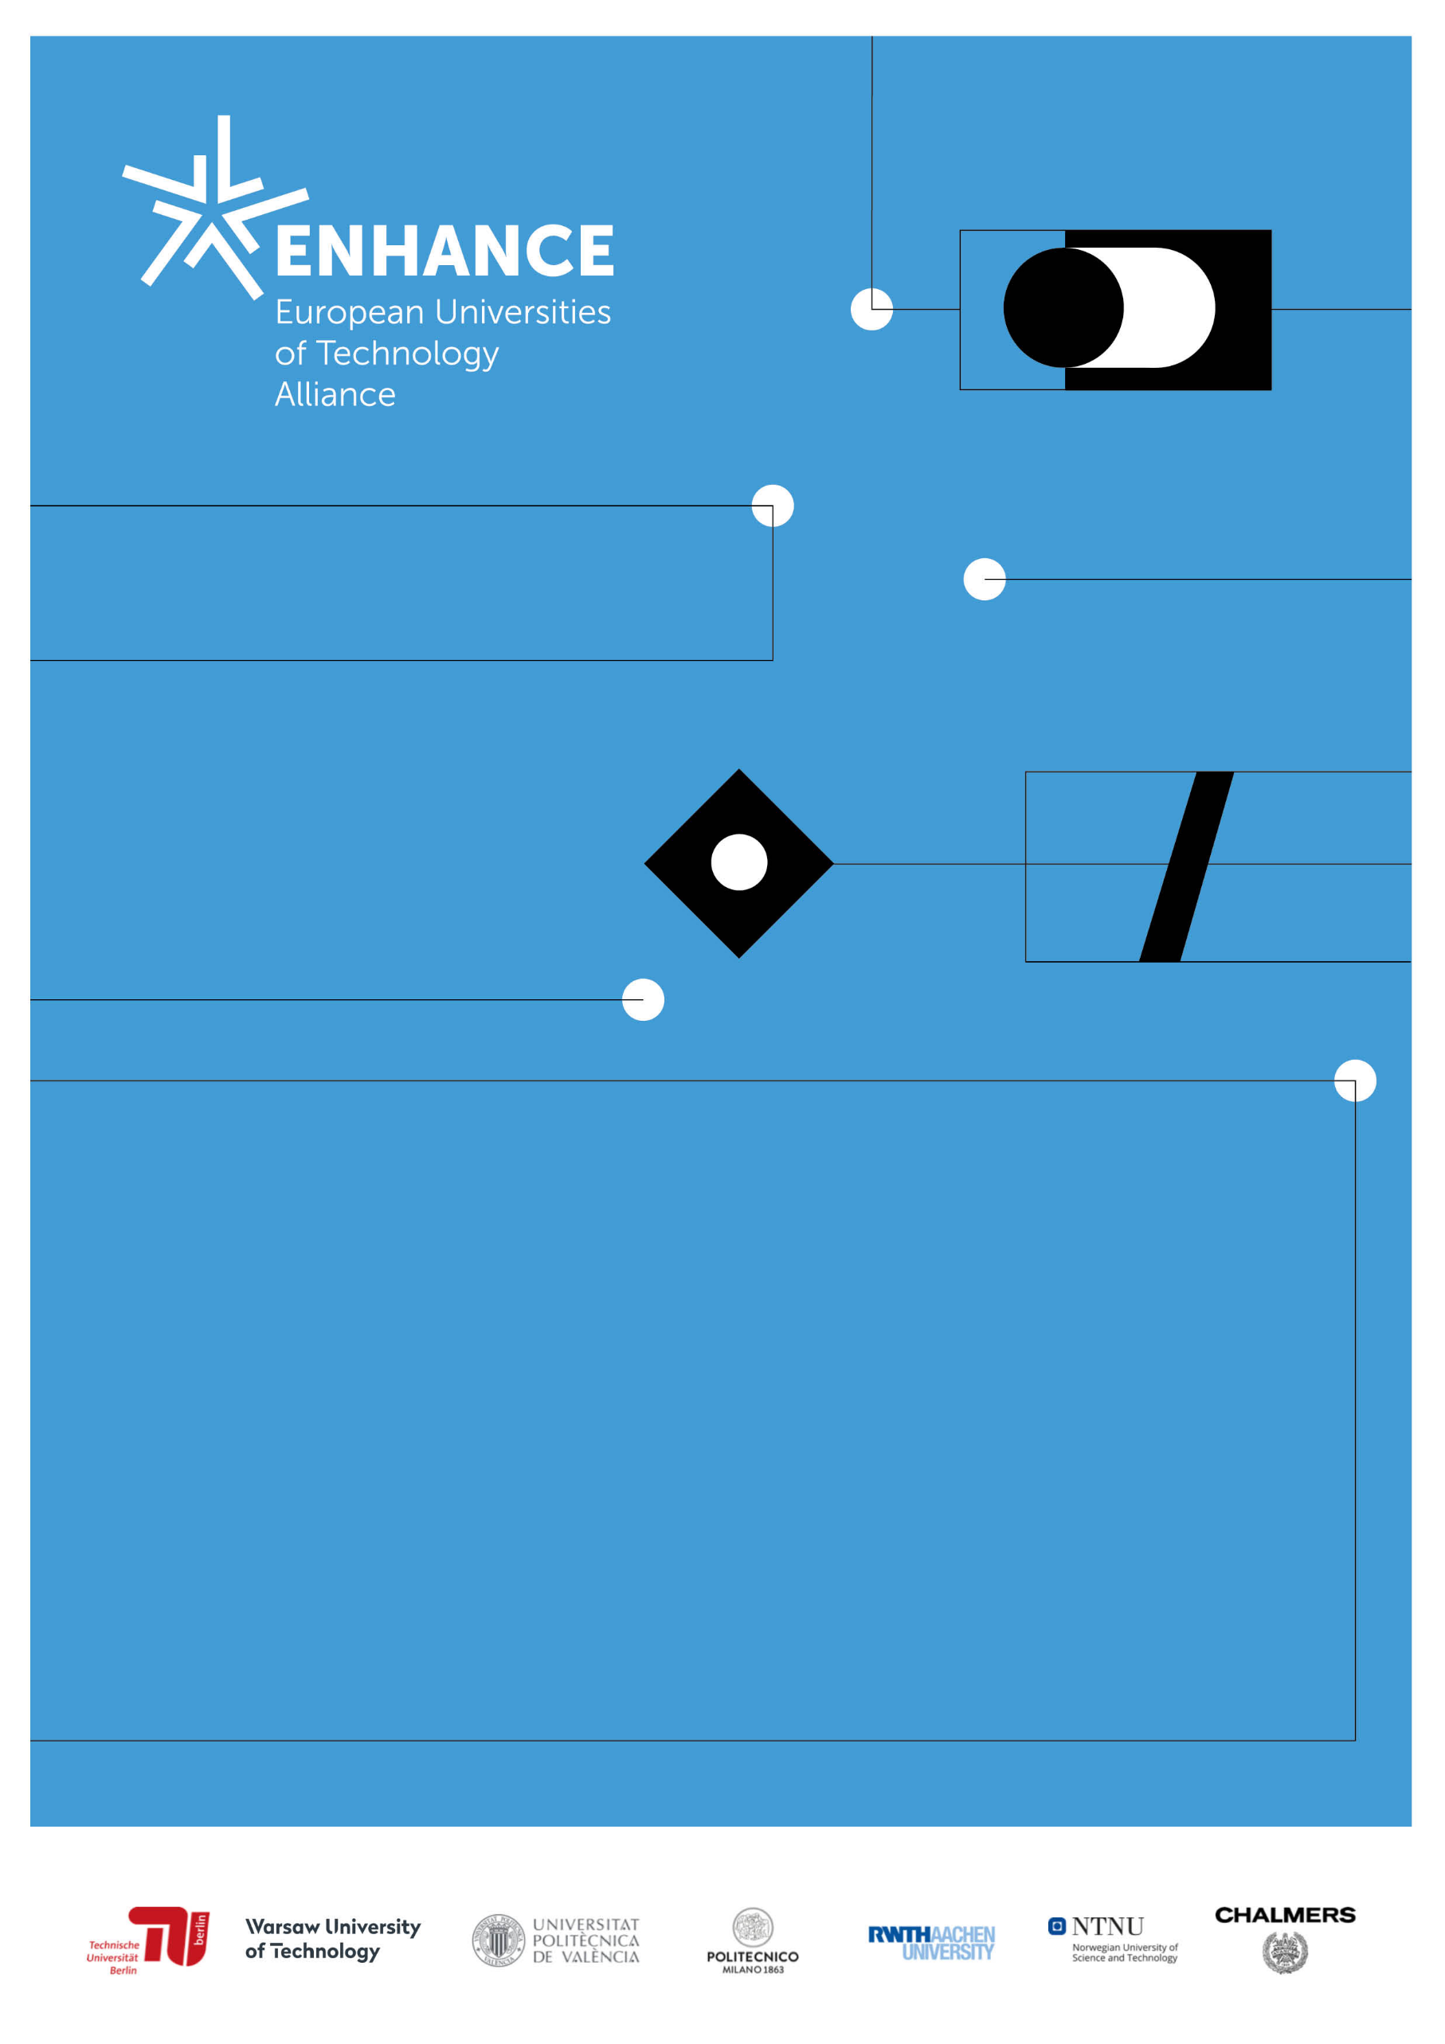

SUPPORT PACK FOR
ENTREPRENEURS AND INNOVATORS
OF ENHANCE

About Diversity and Gender Equality
June 2022

VALUE THE DIFFERENCE
A Concept for
Diversity and Inclusion in Sustainable Entrepreneurship and Innovation (D&I in SEI)

Edited by WP5 and WP6 members (Melih Özkardes, Maria Saline, Kristina Hejdenberg Sedström, Karen Williams Middleton)

Dear ENHANCE Entrepreneur,
This pack is for you to keep. Diversity and Inclusion belong to the core values of the ENHANCE Alliance. It is everywhere. Also in SEI. Can you see it?
Use this support pack to learn, to make a record of your observations, experiences, thoughts, and feelings during your amazing journey in SEI. It is your learning tool and nobody else will read it!
Take notes, spend some time completing this book, use it to help you to discover new insights about diversity and inclusion in SEI and use it to get to know new people to broaden your perspectives and put yourself into the shoes of others. Develop new ideas.
You can write, draw, doodle...Use it however you like. It is a tool only for you.

Now, let’s start with an exercize. How would you draw “Diversity” and “Inclusion”. Draw something that symbolizes for your these two words.

“Diversity” looks like…. “Inclusion” looks like…

Objectives of this support pack
- To reflect critically on diversity and inclusion (D&I) during your SEI related ENHANCE activities
- To explore the connections between SEI and D&I
- To gain awareness of D&I issues (To have some eye-opener and AHA moments)
- To develop a general understanding of these topics

Before we start, let’s understand what we mean by Diversity, Inclusion etc.
Glossary:
Bias: A personal and sometimes unreasoned judgment (Prejudice)
Unconscious (or implicit) Bias: Learned stereotypes and prejudices that are automatic, unintentional, deeply ingrained, universal and able to influence behaviour.
The QR Code is an explainer video for unconscious bias:
Diversity: Embracing and taking into account the differences between individuals and groups of people
Equity: Adjusting for needs to achieve equality.
Gender: A social construct to classify a person as a man, a woman, or another identity such as divers, transgender etc.
Gender Mainstreaming: Integrating a gender equality perspective at all stages and levels of policies, programmes and projects.
(Gender) Equality: Being equal in status, rights or opportunities.
Inclusion / Inclusivity: The practice or policy of including people who might otherwise be excluded or marginalised.
Non-binary: A gender identity that goes beyond the male/female gender binary.
People with fewer opportunities: ‘Young people with fewer opportunities’ are defined in the Erasmus+ programme guide as those young people who are at a disadvantage compared to their peers because they face one or more of the seven exclusion factors: disability, health problems, educational difficulties, cultural differences, economic obstacles, social obstacles or geographic obstacles.

How many of these words did you know before? Write the number in the box:

Think one of the last meetings that you had in the field of SEI. Have you heard any of these words there?

Main idea of D&I in SEI
Work package 5 (WP5) of ENHANCE focuses on Sustainable Entrepreneurship and Innovation Ecosystems. WP5 is dedicated to encouraging a supportive and inclusive culture to promote diversity and build connectivity across disciplines. Recognizing that ENHANCE builds from a technological and academic perspective, the aim is to create an environment in which individual differences and contributions of team members are recognized and valued, and uphold a collaborative environment that promotes dignity and respect. The WP5 facilitates development and dissemination of knowledge contributing to co-creation of value that is societally and environmentally responsible. Diversity is part of the sustainability that consists of economic, environmental and social aspects.
It is about diversity-awareness and inclusiveness in SEI. Entrepreneurship is for all. It is not only for privileged ones. Also (young) people with fewer opportunities* have that talent and innovative ideas that can contribute to a successful SEI process. A successful SEI concept supports entrepreneurs from all backgrounds. Becoming diversity and inclusion aware in SEI means leaving the comfort zone. It comes along with some challenges. It is very important to understand the barriers faced by people with fewer opportunities. This might take more capacity during the entrepreneurial process. But eventually, it fosters unleashing the creative potential that people have within them and using this to create a more sustainable future for all of us. Each individual will benefit from the fact to get everyone on board. This stands for a central value of the SEI concept in ENHANCE.
*Erasmus+ defines (young) people with fewer opportunities as (young) people who, for economic, social, cultural, geographical or health reasons, due to their migrant background, or for reasons such as disability or educational difficulties or for any other reason, including a reason that could give rise to discrimination under Article 21 of the Charter of Fundamental Rights of the European Union, face obstacles that prevent them from having effective access to opportunities under the programme.

Reflections
1. Connection between “D&I” and SEI?
What do you think about the connection between “D&I” and SEI? Make some notes here and talk to your fellows. Make some “desk research” about possible connections.

Have you discovered enough connections between D&I and SEI? Here is an inspirational video about how diversity makes teams more innovative.
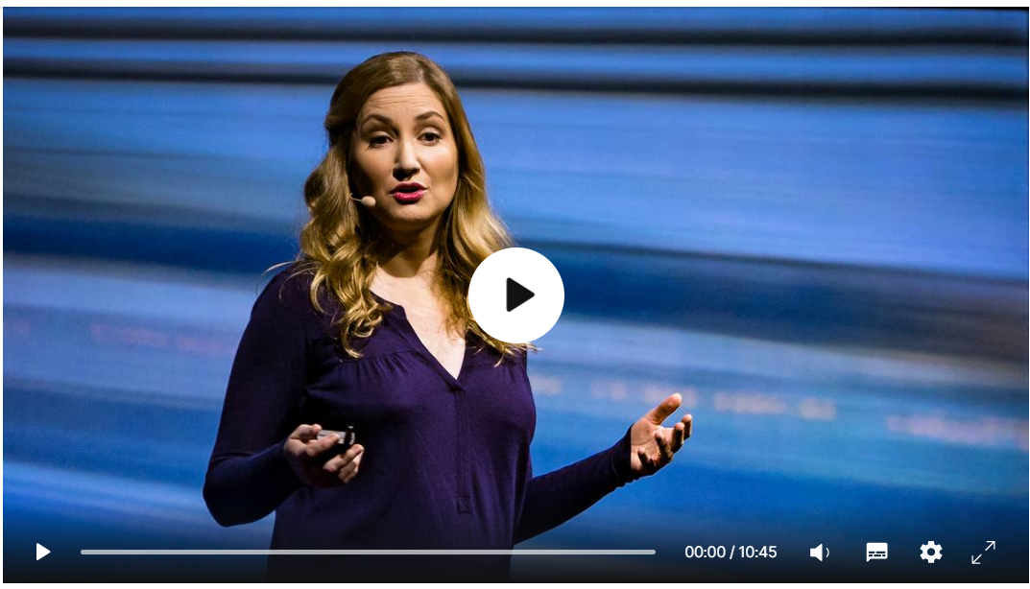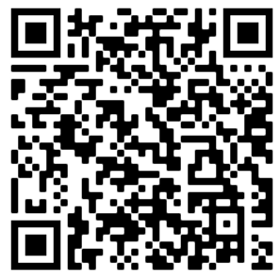
Write down your reflections about this video:

2. Diversity of your team
Successful teams are questioning and listening oriented. They focus on getting the full value of a diverse group.
But how can we become more diverse in our teams? How can we organize this process well? ENHANCE published a guideline that focuses on the aspects of “bias” in selection processes. The topic of “bias” is a phenomenon that needs some attention to become aware of. Understanding and managing our biases helps us to make informed decisions when forming our teams.
The guideline can be downloaded here.
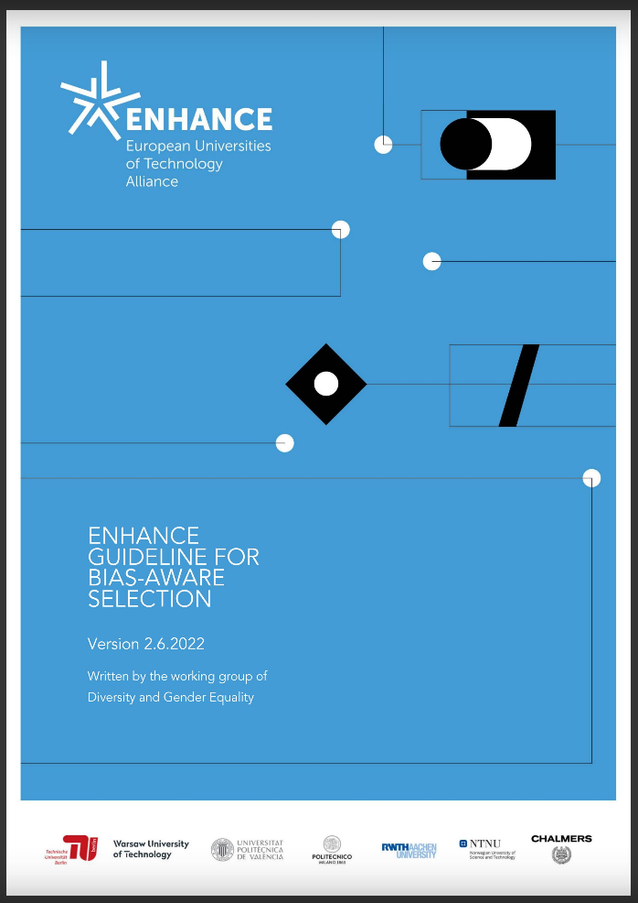
Look at your innovation team now. What kind of diversity do you see there? Please do not forget that not all diversity is visible at first sight. Skin or hair colour, wearing styles, age differences or gender diversity are easier to see. But what about religious and cultural diversity in your group? What about invisible characteristics of your team mates?
Share your observations here:

Talk to someone in your team look different to you at first sight and find out at least three common things you share. Write down your results.

3. Your innovation
Do you think that the innovation you are working on consider the needs of someone with fewer opportunities? If yes, how?
Who is the receiver or the user of your product? Describe them. Look at the general picture that you have. Is this a good picture of the society? Is your product accessible to everyone in the society? Who do you exclude? (There is nothing wrong with it. We just want to make you aware of the consequences of your product design)

What do we need to consider in terms of D&I when developing SEI activities in ENHANCE? Talk to someone about this or ask a question to the presenter of the session that you are attending.
Space for your notes:

4. Training offers in ENHANCE:
Did you know that ENHANCE offers even training opportunities to learn more about Diversity topics? Visit this page to explore the next offers: https://enhanceuniversity.eu/diversity-and-gender-equality/

If you have any questions or comments, feel free to drop a mail to the ENHANCE Ombudsman for Diversity and Gender Equality
Melih Özkardes - Diversity@enhanceuniversity.eu

